

Asia Pacific College

School of Computing and Information Technologies

Magallanes, Makati City

Dash-R-Come

Submitted by:

Hurley Evangelista - Project Manager

Emmanuel Devera - Project Developer

Alyssa Fernandez - Project Analyst

Miguel Matawaran - Project Analyst

Submitted to:

Ms. Rhea-Luz Valbuena

Mr. Manuel Sebastian Sanchez

(Professors)

Mr. Jayvee Cabardo  
(Project Adviser)

Mr. Kenneth Mariano

(Project Consultant)

January 4, 2018

* TABLE OF CONTENTS

**1.2 Purpose and Description 3**

**1.5 Scope and Limitations 4**

**II. Review of Related Software/ Systems 5**

**III. Technical Background 6**

**Hardware Requirements: 6**

**Programming Language Requirements: 7**

**IV. Methodology, Results and Discussion 7**

**4.1 Gap Analysis 7**

**4.2 Requirement Analysis 8**

**4.3 Software Requirements Specification (SRS) 8**

**4.4 Design of Software, Systems, Product, and/or Processes 11**

**Log-in Screen Registration Screen 11**

**Development and Testing 26**

**a. Event Table 26**

**b. Functional Decomposition Diagram (FDD) 29**

**c. Data Flow Diagram (DFD) 29**

**LEVEL 0 Diagram 29**

**LEVEL 1 Diagram 30**

**e. Entity Relation Diagram (With Data Dictionary) 31**

**e. Data Dictionary 32**

**USER 32**

**REPORT 32**

**AGENCY 33**

**DEPARTMENT 33**

**EMPLOYEE 34**

**DASHRCOME 34**

**EMBY 34**

**f. Class Diagram 35**

**g. Object Diagram 36**

**h. Composite Diagram 37**

**i. Use Case Diagram 38**

**k. Activity Diagram 54**

**l. Sequence Diagram 55**

**m. Deployment Diagram 59**

**n. Communication Diagram 61**

**o. Timing Diagram 62**

**p. Component Diagram 62**

**q. Package Diagram 63**

**r. State Diagram 64**

**s. Interaction Diagram 65**

**Results of the Interview 69**

**Results of the Interview 70**

**Results of the Survey 70**

**Change Request 71**

**Curriculum Vitae 78**

**Executive Summary**

The proposed project is an incident reporter system. The team aims to help Pilipinas 911 expand their services in terms of receiving incident reports or complaints. Pilipinas 911 receives incident reports and complaints using their hotline. The problem in their current system, according to Police Chief Inspector Samuel Melchor Fernandez, is that the company cannot verify if the report is true. The team found this as an opportunity for the project implementation. Using the proposed system, Pilipinas 911 will receive a real-time and detailed incident reports online. For the user side, the user is the one sending the incident report to the web server (picture or video), which will be monitored by the Pilipinas 911 employee.  The Pilipinas 911 employee will call for the nearest concerned agency.

**I. Introduction**

**1.1 Project Context**

The proposed project is an Incident Reporter System. The system allows the user to send a video footage or picture of an incident using android device to the system’s web server with required details. The system’s web server will be manned by the Pilipinas 911 employees.

The mobile application is named DASH-R-COME, the mobile application name was composed from the objective before which was to respond quickly. The mobile application runs in Android devices. Incident includes road accident, crime, traffic violators, and exploitation of traffic officers.

The user must have a video footage or picture of an incident captured in either using a dashboard camera or android devices. The user is required to have an Internet connection or mobile data to use the mobile application.

The process of the application, If the user used a dashboard camera to capture the video, then, the user should transfer the video footage or picture to android device using Bluetooth of dashboard camera and android devices (if the dashboard camera has a Bluetooth feature). Otherwise, the user has to transfer the memory card of dashboard camera to the android device and save the video footage or picture to the android device’s file system, such as Gallery. If the user used an Android device in capturing a video footage or picture of an incident, then the user can simply save the video footage or picture to the android device’s file system.

For the video cutter feature, the user can use third party software where the user can cut unnecessary clip. The importance of cutting the unnecessary part is less consumption of the memory and less-usage of mobile data/Wi-Fi connection. If the user used the feature of ‘Take a snap’ feature, it will only limit to 30 seconds, after 30 seconds the user can either delete or save the captured video footage, thereafter the user can take another 30 seconds video footage. After the user has the video footage or picture saved in his/her android device, then the user can upload the video footage or picture to the system’s web server using the mobile application. The uploaded video will be analyzed by the person in-charge of monitoring the web system’s server in Pilipinas 911. Analyzing the video means to categorize the incident type, such as crime, traffic violators, and exploitation of traffic officers, fire.

After analyzing the incident report, the employee in-charge will generate an incident report which will be forwarded to the leading designated agency (Barangay, Police, Hospital, Fire bureau).

## **1.2 Purpose and Description**

DASH-R-COME is a mobile application that can be used to report accidents, crime, and fire incidents. The application can also serve as evidence in times of involvement in a situation such as road accident. Using the proposed system, the user can send a picture or video footage of an incident to the system’s web server using any Android device or dashboard camera. The system’s web server will be operated by the Pilipinas 911 employees.

The purpose of the project is to provide the client a system that could help them get a real-time events or incident reports using the report of the user. Also, to provide the client an updated record of incidents that could be used in crime statistics purposes.

**1.3 Objectives**

* To expand the scope of Pilipinas 911 services in terms of receiving incident reports.
* To provide the client real-time and detailed incident reports.
* To provide the client records of incident that occurs monthly.
* To provide evidence or supporting details when reporting an incident to the client.
* To provide evidence that can help the user in future use. (e.g. Dishonesty of the latter to the his/her fault)

**1.4 Application’s Features**

* Login system feature to authenticate the user and to avoid fake reporters.
* A third party video cutter feature to reduce the file size and data that will be consumed.
* 'Take a snap' feature that allows user to send only a picture of an event.
* 'DashBlue' feature that allows user to transfer the video footage of the incident from the dashboard camera to the android device.
* 30 seconds limitation for capturing to video footage to reduce the memory used.

## **1.5 Scope and Limitations**

The scope of the project is the whole Philippines. The group target users of the mobile application are the motorists, bystanders, constituents and android device users. In order for the user to use the mobile application, the user must register to the mobile application and must have an internet connection or mobile data. Also, the user must have a picture or video footage of the incident captured that will be uploaded later on to the web server, which is being operated by Pilipinas 911 employee. In capturing pictures or videos, the user has three options, first, the user can use dashboard camera and transfer to the android device with its Bluetooth feature (the two devices must have a Bluetooth capability), second, if the user had captured the video footage with his/her android device, it must save in the android’s file system such as, Gallery and upload in the application from the file system, and third, the ‘take a snap’ feature to directly capture the video footage in the application that has 30 seconds limitations.

If the user does not have an internet connection, then the application cannot be used to emergency situation. The project will not be covering the responding part of 911 Pilipinas and the desired leading agency. The proposed project is only limited in generating incident report that will be forwarded to the desired leading agency.

# **II. Review of Related Software/ Systems**

2.1 iWrecked - Nobody would want to get involved in an accident, but, a fact that accidents do occur every single day remains. If you are ever caught in an accident, you would want an application such as iWrecked, to key in and keep a history of the complete relevant details, preview and send accident reports, and look for towing services.

The group aims to provide a button that has the telephone of the agency in the application in order to respond quickly, and to provide evidence handling and to send help to the user as quickly as possible.

JohnnyJet (2017, August) Retrieved from https://www.johnnyjet.com/travel-app-of-the-week-iwrecked

2.2 Spotted Incident Reporter - Spotted incident reporter application is a local crime track, report and information on stolen cars and accidents. Spotted incident reporter application is a local crime track, report and information on stolen cars and accidents. For example, a car was stolen 6 minutes ago, you had the power to fight back to the thieves who stolen the car by posting the incident in the app, including the pictures of the stolen property or car. A feature of Global positioning system (GPS) that track the location of the said event.

Also, the team's proposed application provides evidence handling such as The location, day, time, and video or picture of the incident occurred, then sends directly to the desired agency that would respond to the reported incident by the user.

APKfilez (2017, August) Retrieved from <https://apkfilez.pw/io-applickable-spotted-apk/>

2.3 Incident Reporter - Incident reporter is an online cloud-based that is available anywhere. By using this application, you can communicate and document incidents. The features of this. The application is using a global positioning system, customizable interface, past report of the user can easily retrieved and it uses SMS. Our application can find you The nearest local government unit by our artificial intelligence system, it would require to enable your GPS in your device. It also lets the user to be notified upon the uploaded incident video report when it reaches to the agency. You must also have a data or an internet connection to use the application in order to find the nearest local government unit.

Technolgy APKpure (2017, August) Retrieved from https://apkpure.com/incident-reporter/com.magikminds.marbles.plugins.incidentreporter

## **III. Technical Background**

The group considered the technology that a must in developing the project. This section shows the availability of the following requirements in developing the proposed project.

Software Requirements:

* Android Studio - Built based on JetBrains' IntelliJ IDEA software and designed specifically for Android application development. It is developed by Google that is based on the Linux kernel which are similarly deployed on a traditional computer system.
* Emby - is a media management server that allows you to synchronize media libraries, watched status, and watch progress between compatible devices. It is an open source software created by Emby Team.
* Firebase - is a mobile and web application development platform developed by Firebase. It is used to develop high-quality apps and in businesses.

## 

## **Hardware Requirements:**

* Operating system runs at least Android 4.0 (Ice Cream sandwich) or higher.
* ·At least 1GB RAM
* 4 “screen
* ·1500 mAh battery
* Android devices - A handheld device that will be used by the motorist to upload the video or picture that was captured from the dash camera.
* Computer - A device that acknowledges data and controls it for some outcome based on the program or set of instructions on how the information is to be handled.
* WiFi / Router - To be used on different purposes such as data transmission and wireless communication.

## Programming Language Requirements:

* Java - is the innovation of decision for building applications utilizing structured codes that can be executed on cell phones and this is what the group will mainly use for developing the mobile application that will serve as the interface between the user and the system. In addition to, it is a general-purpose computer programming language and has been in existence for over 2 decades.
* SQL (Structured Query Language) - is a systematized programming language utilized for managing relational databases and performing different operations on the information given. The proponents of the project are planning to use SQL to create online database where the users of our project will store the videos.

# IV. Methodology, Results and Discussion

## 4.1 Gap Analysis

|  |  |  |  |
| --- | --- | --- | --- |
| Dash-R-Come | | | |
| User Requirements | Current System | Goal | Proposed Changes |
| 1.To be able to report an incident or crime with a global positioning system (GPS) location | A reporting application lacks of notification to the user who uploaded the incident. | To have an evidence and help local government units. | Dash-R-Come will provide a Bluetooth handshake connection and file system where users can upload either of these two |

## **4.2 Requirement Analysis**

The group aims to develop a mobile application for Incident Reporting. The user must register to the mobile application in order to have a verified account. To register, the user can either link his/her Facebook and Gmail account or create a new account. After the successful registration, the user must login to use the application. There are four (4) choices, the Dash-cam blue, take a snap, Upload through the file system and Settings. The dash-cam blue is a feature that needs a dashboard camera that has Bluetooth. The application will request for the permission to turn on the Bluetooth in order to transfer the file that is stored in the dashboard camera. Take a snap will be directly to the android device’s camera, either captures a video or picture. Once the user gets a video footage of an incident, the user can use the video cutter feature of the mobile application to cut the unnecessary parts. Upload through the file system, the user will choose a picture or a video of an incident to sent to the agency from the file system of the android device. The settings contain edit full name, update email, and update phone number and logout.

## **4.3 Software Requirements Specification (SRS)**

|  |  |  |  |  |
| --- | --- | --- | --- | --- |
|  | ASSIGNED TO | YES | NO | REMARKS |
| Output  ✓ The mobile application will display a message if the user has successfully registered to the mobile application    ✓ The mobile application’s database shows the list of registered users    ✓ The mobile application will display a message if the user has successfully sent the video to the web server.    ✓ The agency must send feedback to the user  ✓ The employee monitoring the web server must leave a comment to the picture/ video he/she has validated |  |  |  |  |
| Input    ✓ The user must be connected to Wi-Fi or Mobile data to open the mobile application  ✓ The user must have a video to be sent to the agency  ✓ Each input field must be complete. Such as, name, contact number, and email address  ✓ The user can cut the video using the mobile applications’ feature    ✓ The user can transfer the video captured using a dashboard camera to the android device    ✓ A confirmation window to provide the user a confirmation of his/her action. |  |  |  |  |
| Process  ✓The user must be connected to the internet or mobile data  ✓The user has to register to use the mobile application  ✓The user must upload the video footage/ picture of an incident filmed using android device or dashboard camera to the web server  ✓ The employee assigned to the web server will identify the type of incident that was uploaded to the web server[Fire, crime, road accident, unforeseen event]  ✓ The employee assigned to the web server will generate an incident report which will be forwarded to the desired agency |  |  |  |  |
| Performance  ✓The device must be an android device with a Operating System (OS) minimum of Kitkat.  ✓The system must be online 24/7    ✓ The system must be responsive  Control  ✓ The system must provide a login system to avoid prank reporters [RV1] and the login should take 15-30 seconds.    ✓ The system must maintain user integrity.    ✓ The user must allow the camera, Bluetooth, cellular data and Wi-Fi connection permission for the mobile application.    ✓ The users must read the play store policies against the potential harmful or threat party software. |  |  |  |  |

## 

## **4.4 Design of Software, Systems, Product, and/or Processes**

## Log-in Screen Registration Screen

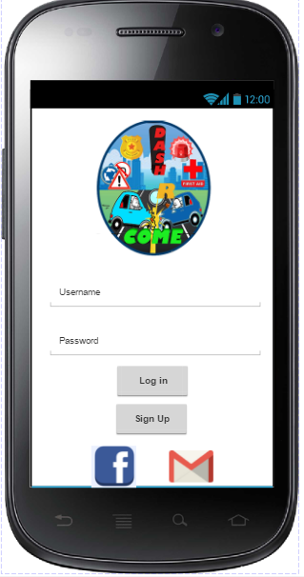 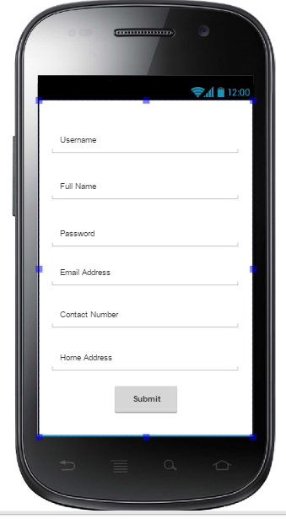

Successful Registration

Screen Link Facebook Account

to application Screen

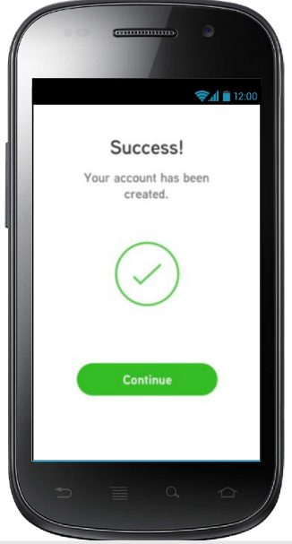 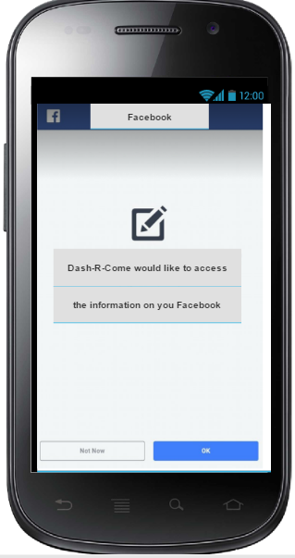

Link Account from GMAIL Log-in Failed Screen

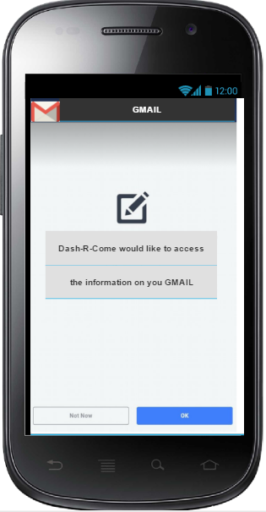 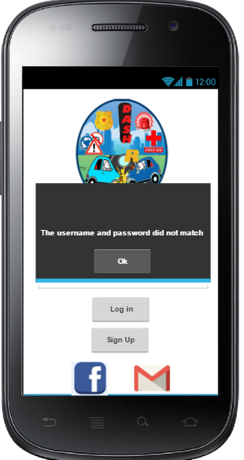

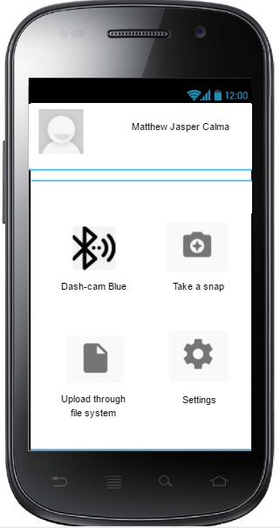 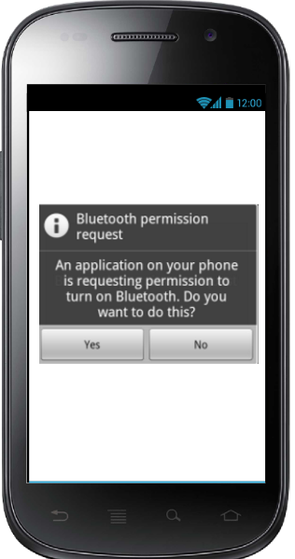

Home Screen Bluetooth permission Screen

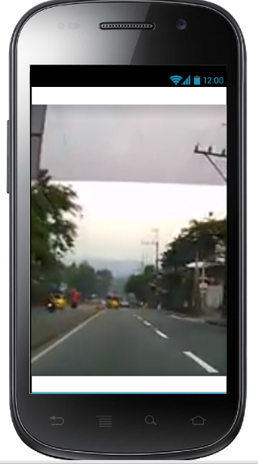 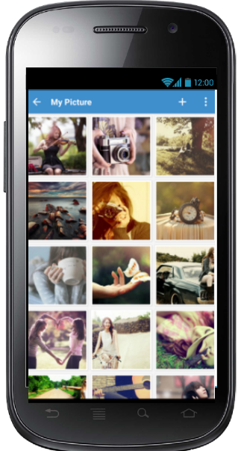

Take a Snap File System

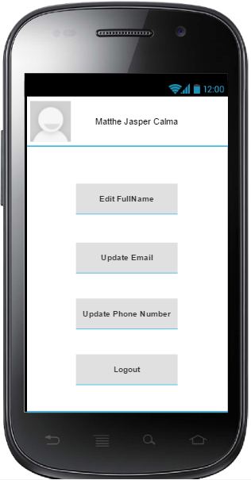 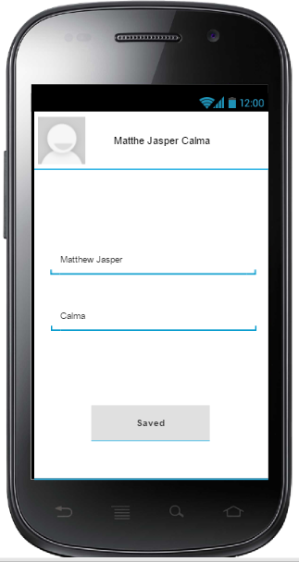

Modified User’s Account

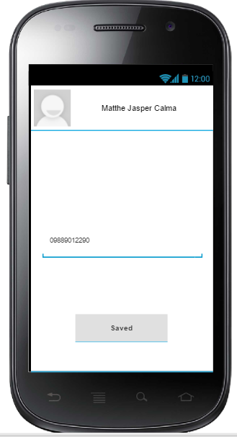 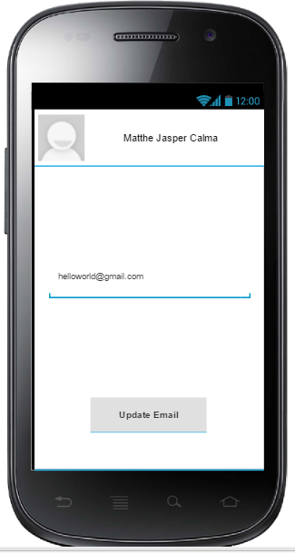

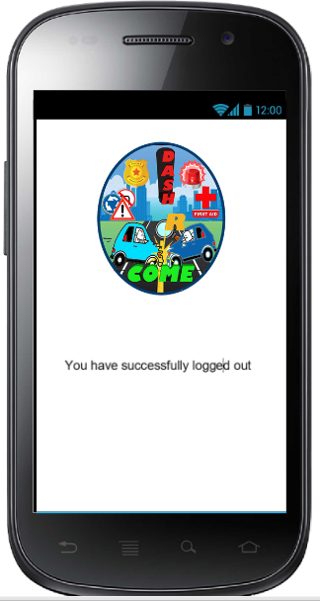

Log out Activity

Administrator Using Emby Web Application

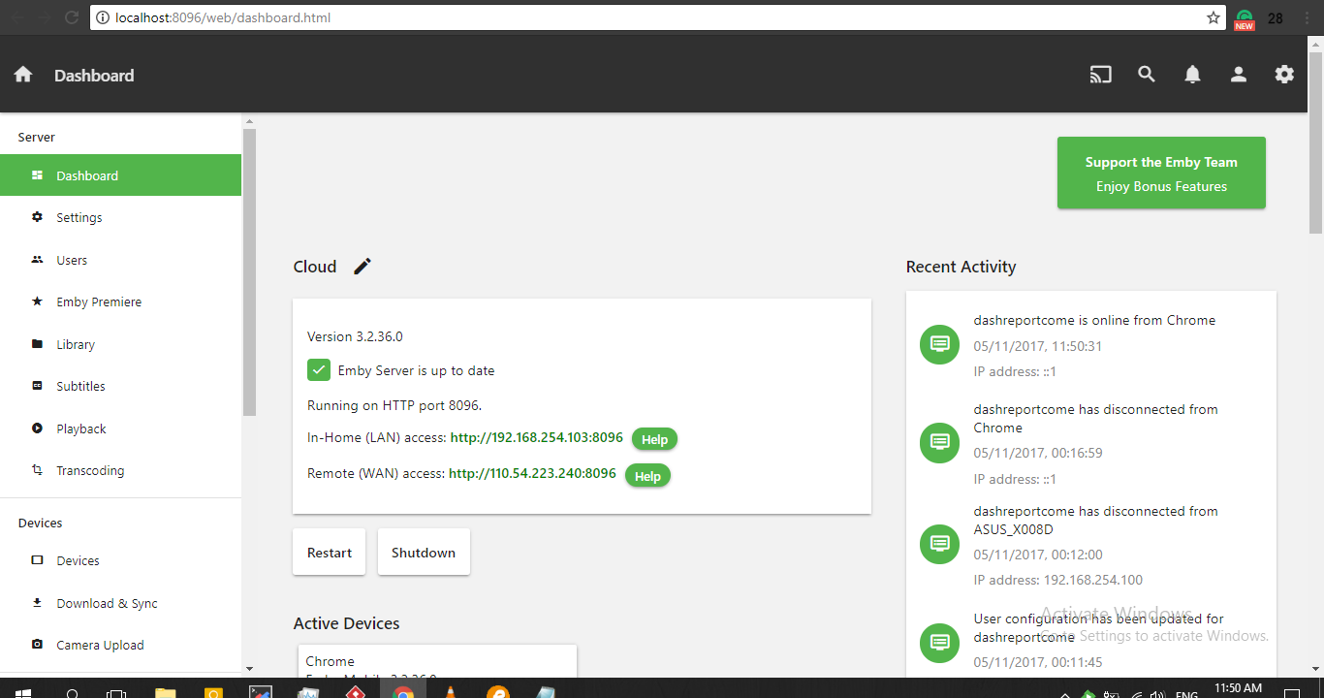

The Dashboard of Emby - It has WAN (Wide Area Network) and LAN (Local Area Network)

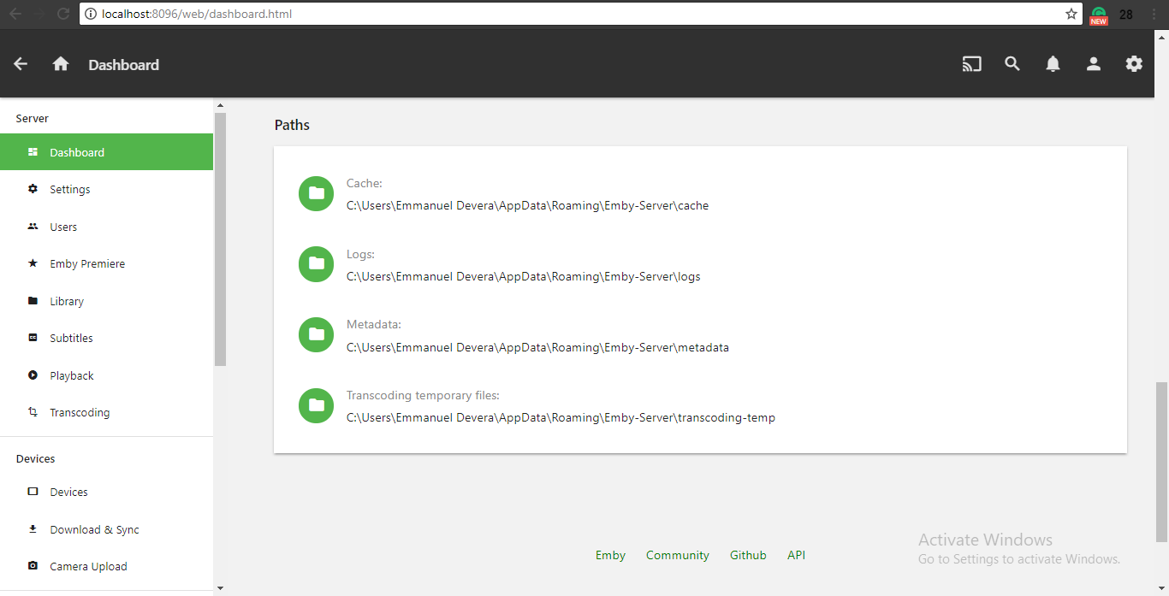

Server Logs

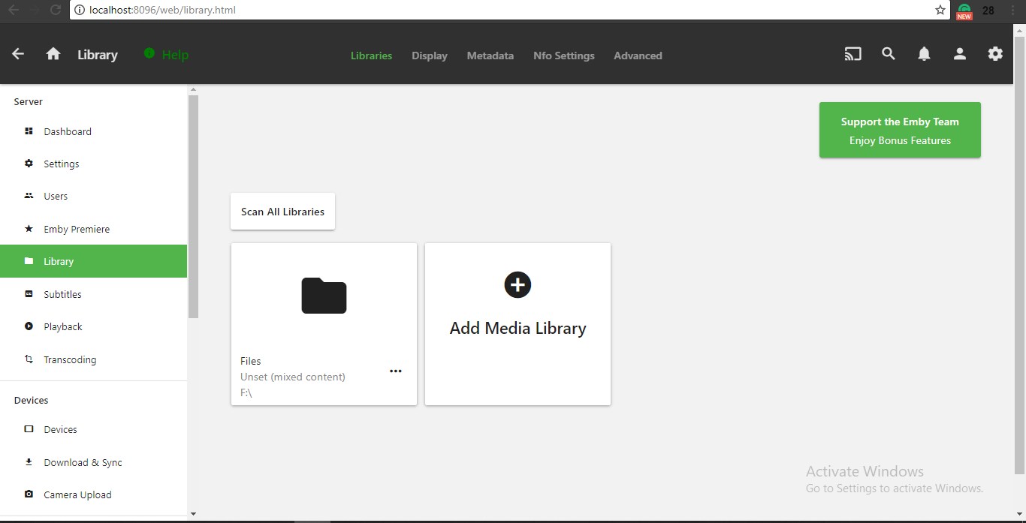

The folder where the pictures and videos were stored

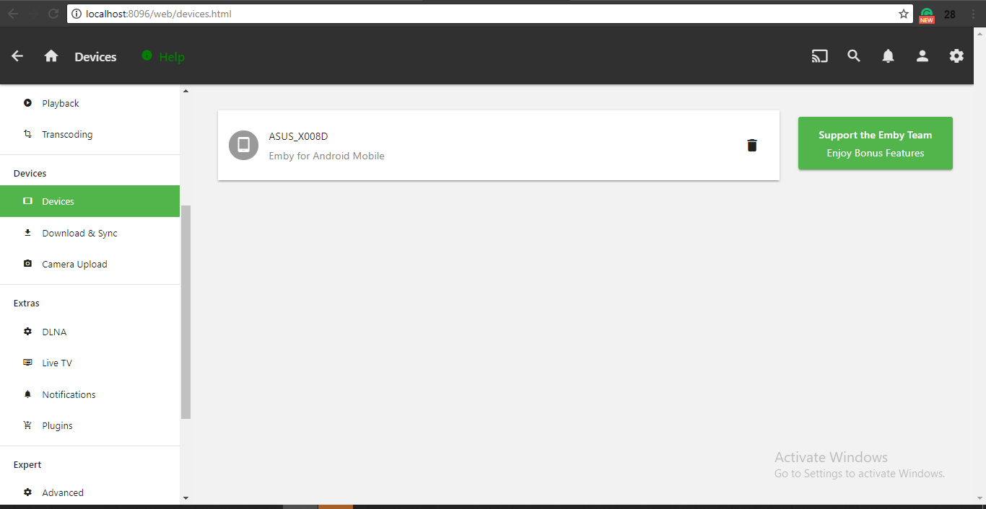

Devices that connected to the Emby Server

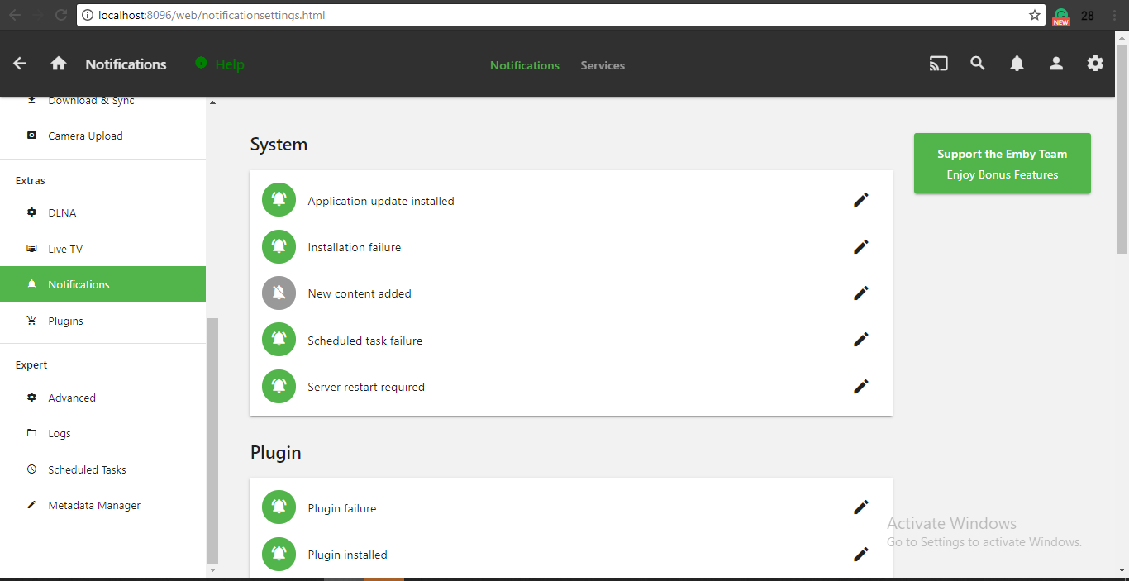

System Features Part 1

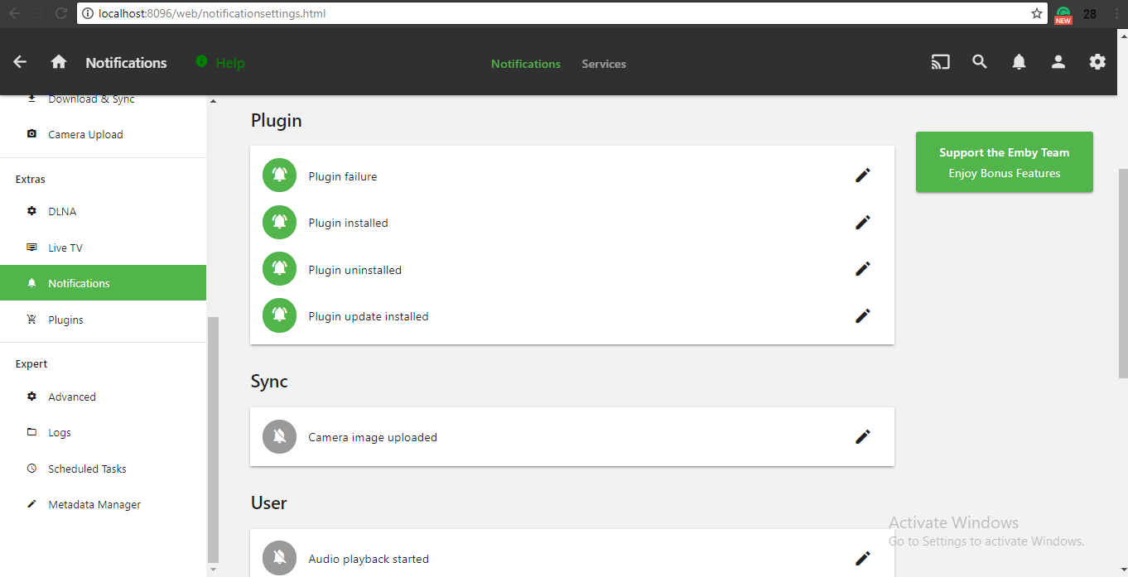

System Features Part 2

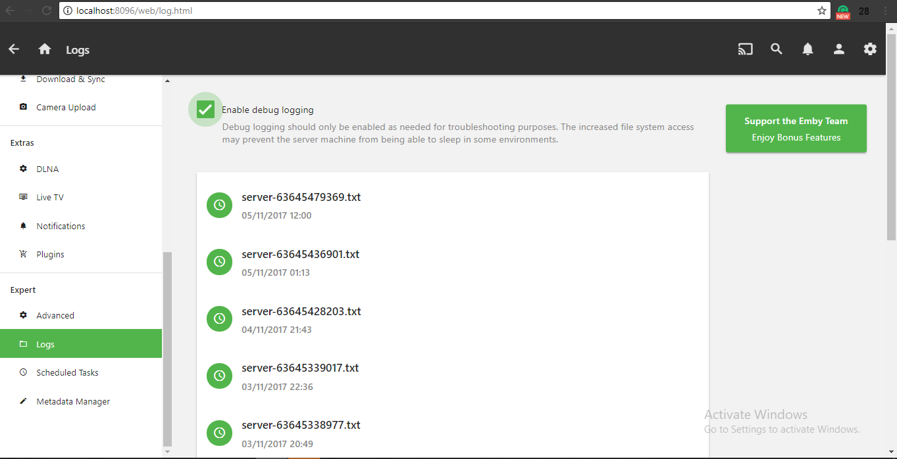

Server logs contained what was the date the user accessed and what time the user accessed

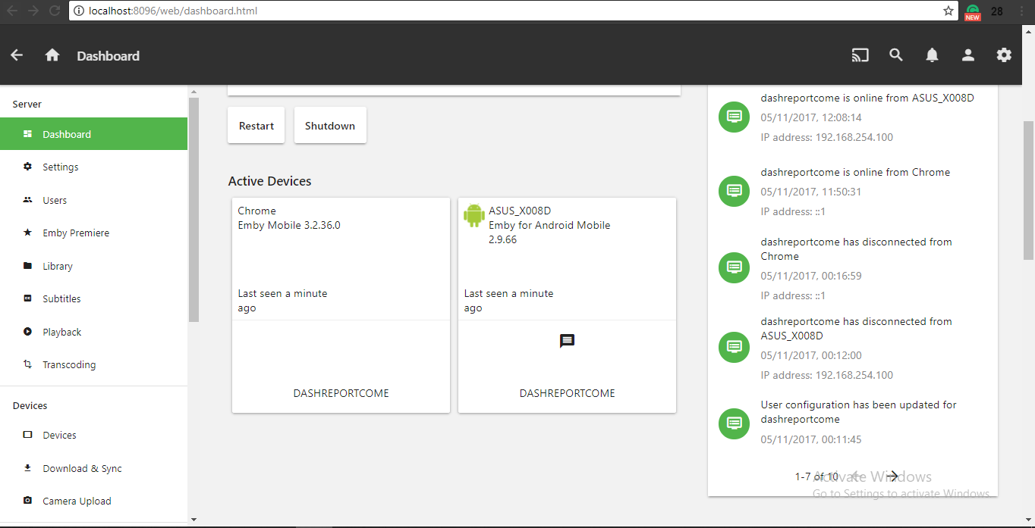

Real-time Monitoring of Active Devices

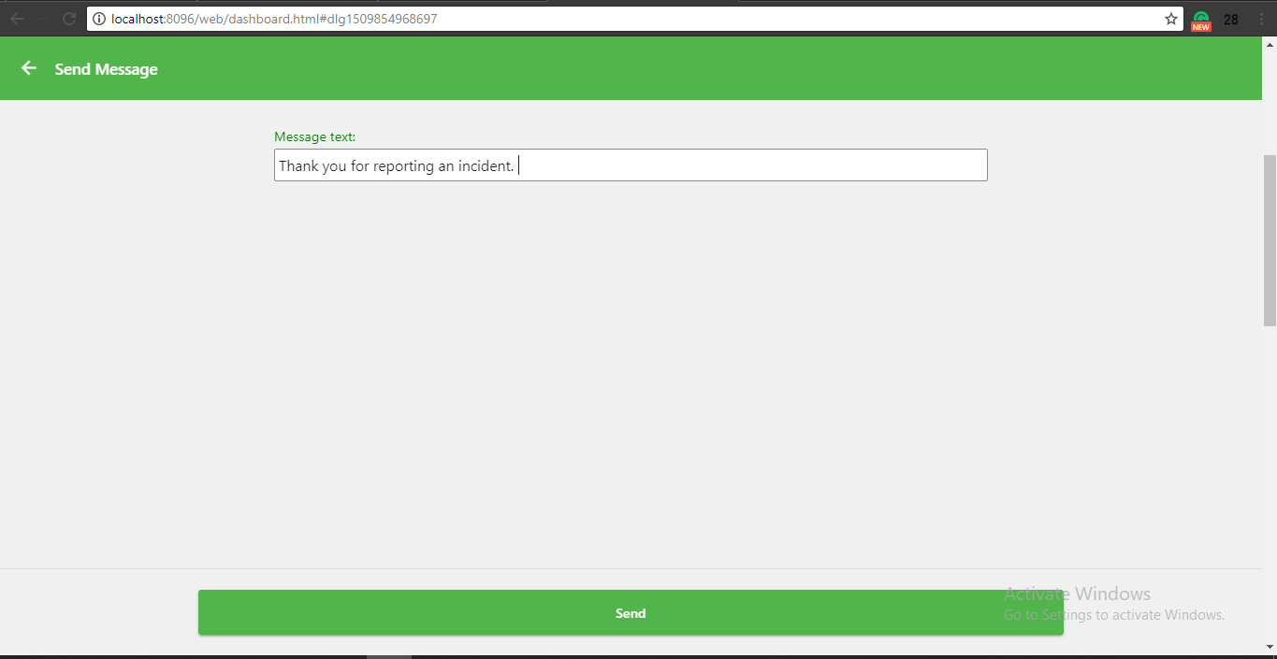

Administrator Message Panel - Message the specific user if the report has been taken an action

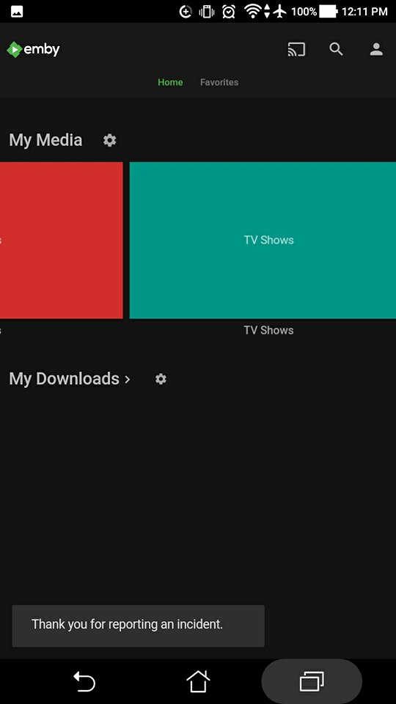 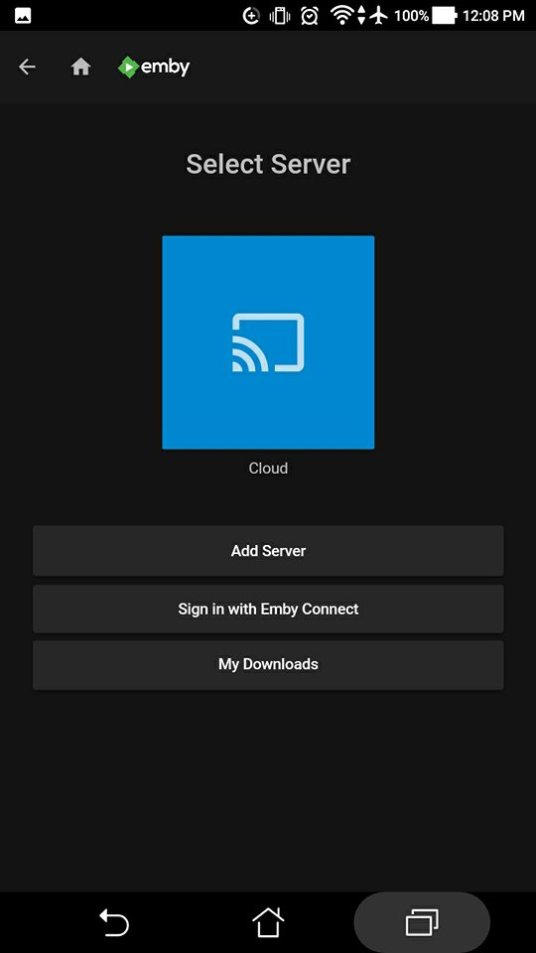

User received the message

Personal Computer of the Agency that serve as a media server. The a0dministrator can monitor through the admin mobile application

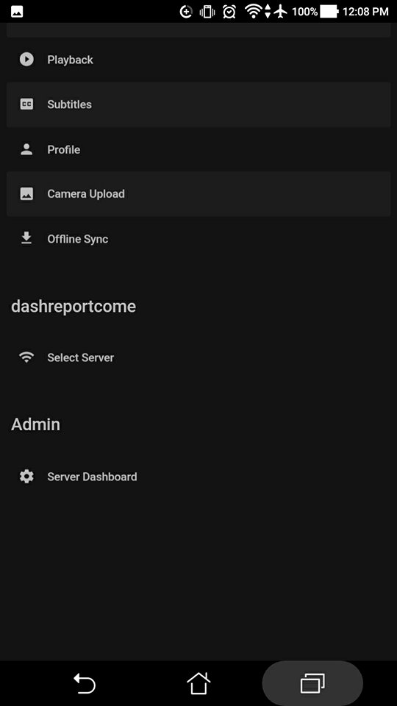 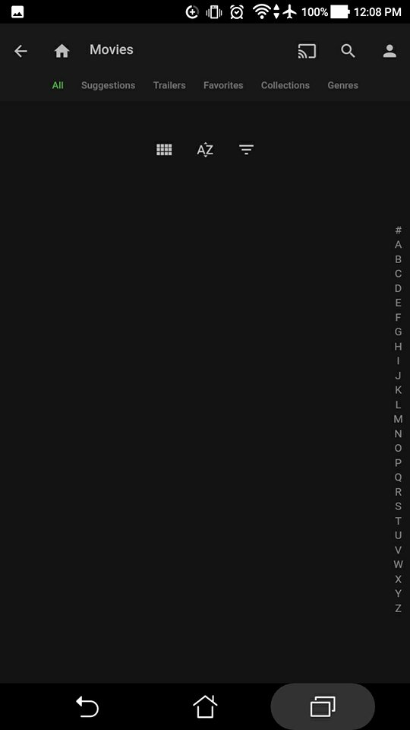

Settings and the ascending or descending order of files.

## **Development and Testing**

The prototype that the team will be developing is powered by Android Studio and Emby API. Android Studio is the main tool for developing android application. It provides the fastest and efficient way to build a mobile application. Emby Application Programming Interface (API) is directly and as part of the integration. Determine if they meet the functionality, reliability, performance and security. The prototype would enable the developers to create the proposed project. System testing gains the developers to verify that the system will handle all input data properly, both valid and invalid.

### Event Table

|  |  |  |  |  |  |
| --- | --- | --- | --- | --- | --- |
| Event | Trigger | Source | Use Case/ Activity | Response | Destination |
| User wants to Login to the Mobile Application | User wants to use mobile apps features | User | Display Login Fields | Displays main screen after a successful login. | User |
| User wants to upload either picture or video footage | An incident occurred | User | The mobile application displays the features of the application (DashBlue, Take a Snap, Upload from File System, Trim Video) |  | Emby |
| User wants to trim the video | The uploaded video has big file size/video is too long | User | Gets the uploaded video footage | The mobile application displays the link to direct the user to third party video cutter | Android file system |
| Captured Video has reached 30 seconds | User used the ‘Take a Snap’ Feature in the Application | User and Mobile Application | Stop automatically after the Video footage has reached 30 seconds | Displays Delete or Take an another message box. | Mobile Application |
| Pilipinas 911 employee received an incident report | An incident report has been uploaded to the Emby | User | Prompts the employee to Log in to the Emby | Emby displays the incident reports. | Emby |
| Pilipinas 911 must categorize, validate and analyze the incident report. | Pilipinas 911 had successfully log in to the Emby and has access the Incident Report of the User. | User | Emby displays the Incident Report of the User. |  | Emby |
| Pilipinas 911 employee must give comment to the Incident Report in the Emby for Update Status(Notification) | Pilipinas 911 employee had notify the desired leading agency. | Pilipinas 911 employee | Displays the comment section in the Incident Report and gets the comment of the employee | An update status (Notification) | User |
| User must receive a notification indicating the update status of his/her submitted incident report | The agency had analyzed, validated and categorized the incident report submitted by the user. | Pilipinas 911 Employee | Emby sends the comment of the Pilipinas 911 employee to the email address of the User | Mobile Application displays the update status (notification) | User |
| Desired leading agency employee received an report from Pilipinas 911 and wants to Login to the Emby | Pilipinas 911 notified the desired leading agency. | Pilipinas 911 employee | Prompts the employee to Login to the Emby |  | NONE |
| Pilipinas 911 or Leading Agencies must generates an agency report(compilation) | An incident report has been dispatched/ solved. | Pilipinas 911 or Leading Agencies | Displays the generating an agency report fields | Generated Agency report (Compilation) | Pilipinas 911 or Leading agencies’ System |

### 

### **b. Functional Decomposition Diagram (FDD)**

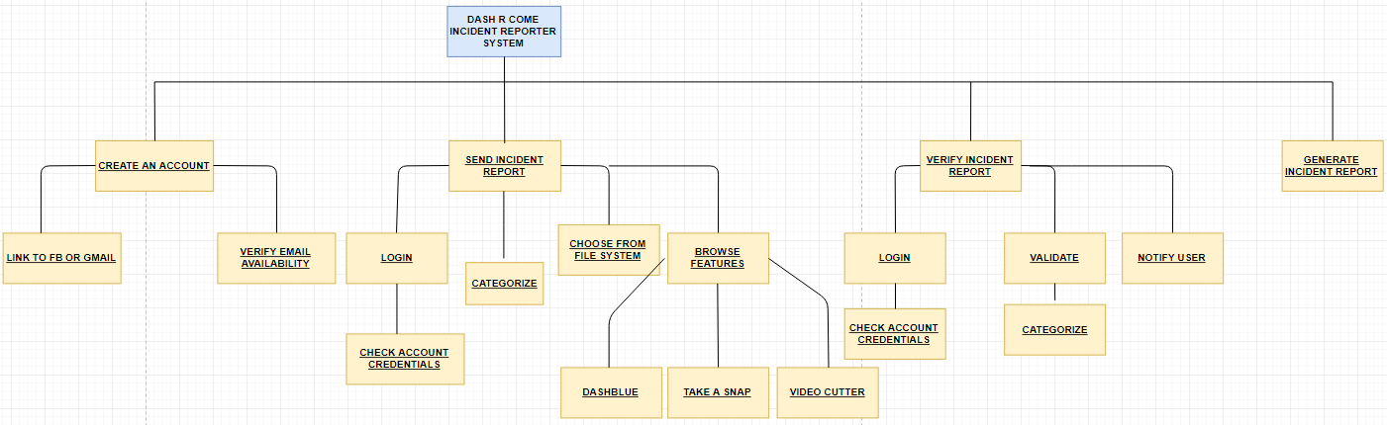

### **c. Data Flow Diagram (DFD)**

#### **LEVEL 0 Diagram**

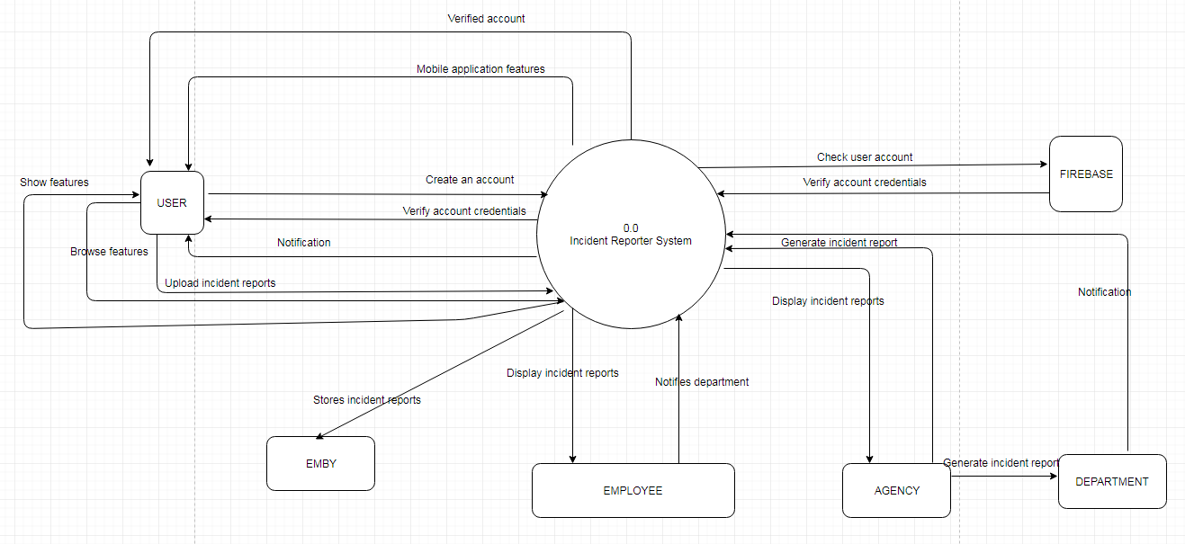

#### **LEVEL 1 Diagram**

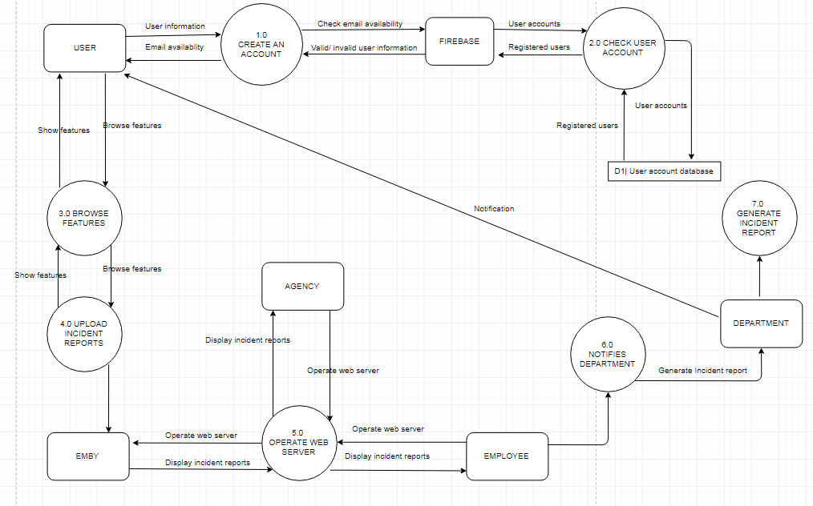

### **e. Entity Relation Diagram (With Data Dictionary)**

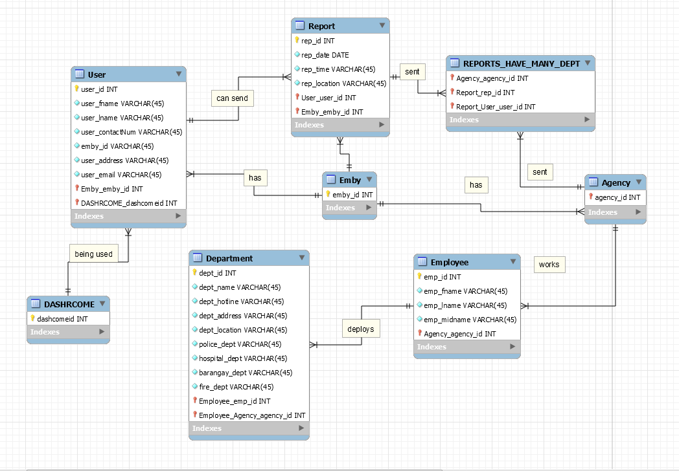

### **e. Data Dictionary**

#### USER

|  |  |  |
| --- | --- | --- |
| Field Name | Caption | Data Type |
| user_id | User id | INT |
| user_fname | User first name | VARCHAR(45) |
| user_lname | User last name | VARCHAR(45) |
| user_contactNum | User phone number | INT(11) |
| emby_id | User emby id | INT |
| user_address | User home address | VARCHAR(45) |
| user_email | User email address | VARCHAR(45) |

#### REPORT

|  |  |  |
| --- | --- | --- |
| Field Name | Caption | Data Type |
| rep_id | Report id | INT |
| rep_date | Report date | DATE |
| rep_time | Report time | VARCHAR(45) |
| rep_location | Report location | VARCHAR(45) |

#### AGENCY

|  |  |  |
| --- | --- | --- |
| Field Name | Caption | Data Type |
| agency_id | Agency identification | INT |

#### DEPARTMENT

|  |  |  |
| --- | --- | --- |
| Field Name | Caption | Data Type |
| dept_id | Department id | INT |
| dept_name | Department name | VARCHAR(45) |
| dept_hotline | Department hotline number | VARCHAR(45) |
| dept_address | Department address | VARCHAR(45) |
| dept_location | Department location | VARCHAR(45) |
| police_dept | Police Department | VARCHAR(45) |
| hospital_dept | Hospital Department | VARCHAR(45) |
| barangay_dept | Local Government Unit | VARCHAR(45) |
| fire_dept | Fire Department | VARCHAR(45) |

#### EMPLOYEE

|  |  |  |
| --- | --- | --- |
| Field Name | Caption | Data Type |
| emp_id | Employee id | INT |
| emp_fname | Employee First Name | VARCHAR(45) |
| emp_lname | Employee Last Name | VARCHAR(45) |
| emp_init | Employee Middle Initial | VARCHAR(2) |

#### DASHRCOME

|  |  |  |
| --- | --- | --- |
| Field Name | Caption | Data Type |
| Dashcomeid | Mobile application | INT |

#### EMBY

|  |  |  |
| --- | --- | --- |
| Field Name | Caption | Data Type |
| emby_id | Emby server | INT |

### **f. Class Diagram**

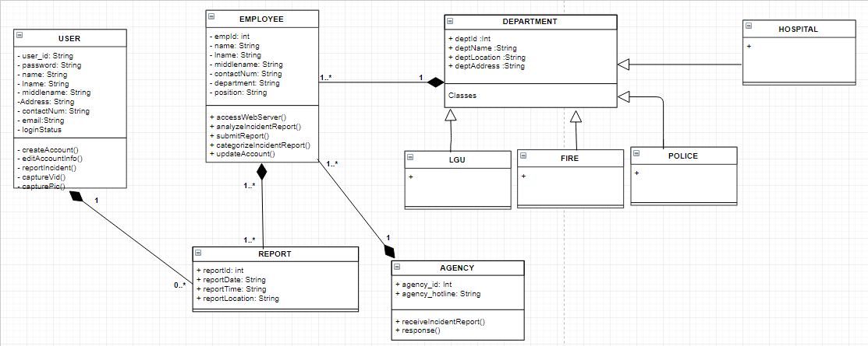

### **g. Object Diagram**

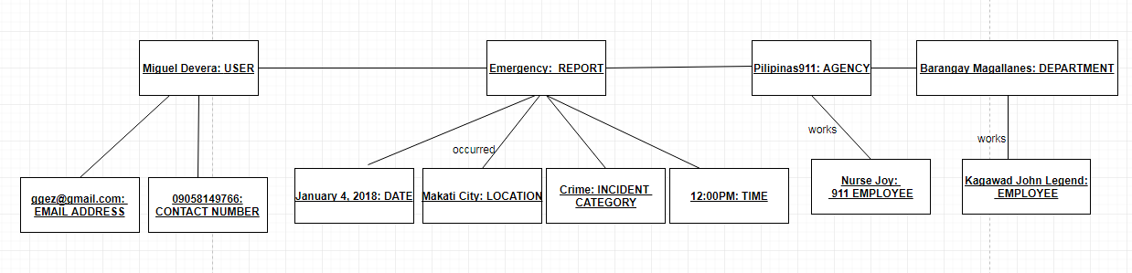

### h. Composite Diagram

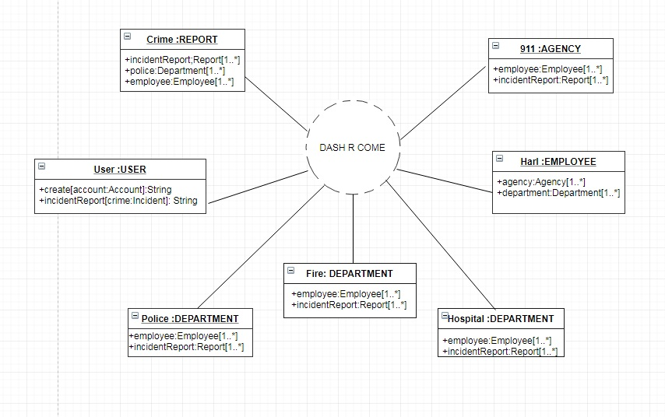

### **i. Use Case Diagram**

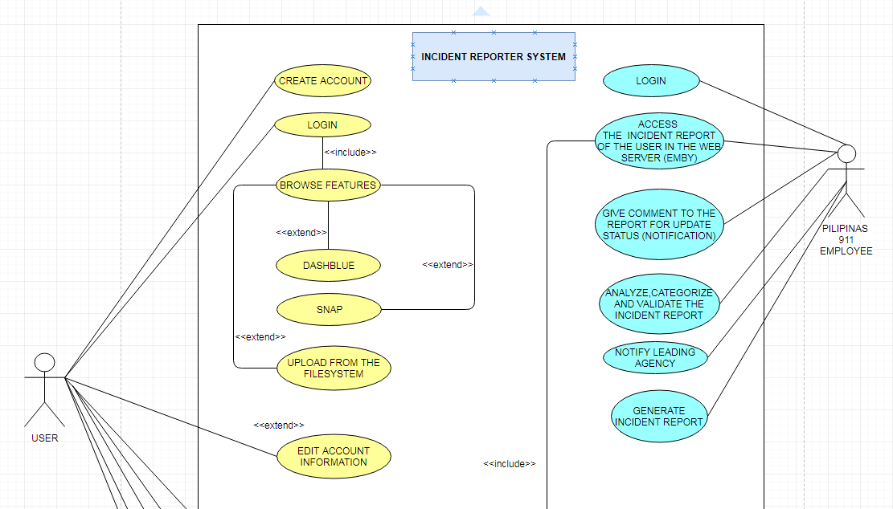

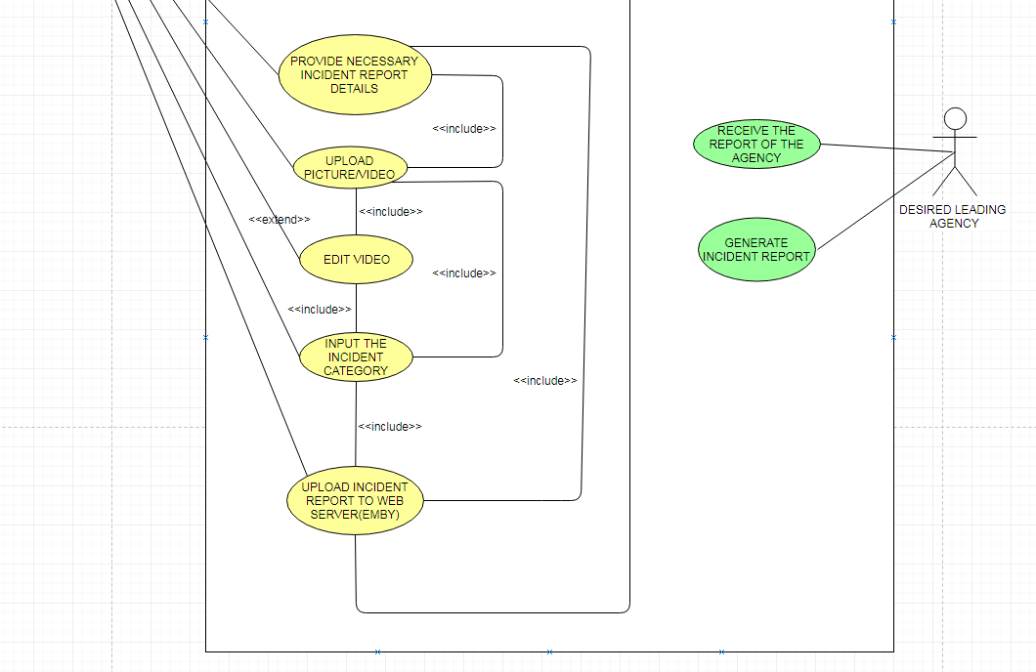

**j. Use-Case Full Description**

|  |  |  |
| --- | --- | --- |
| Use Case Name: | Create an account | |
| Scenario: | User wants to create an account | |
| Triggering Event: | Registration | |
| Brief Description: | User wants to create an account to use the mobile application. | |
| Actors: | User | |
| Related Use Case: | Browse Features, Edit account information, Edit video, Upload Incident Report to Emby. | |
| Stakeholders: | User | |
| Preconditions: | • The user must install the mobile application to his/her android device.  • The user must register to the system.  • The user must have internet access to use the system. | |
| Postconditions: | The system will store the data entered by the user to the Web Server. | |
|  |  | |
| Flow of Activities: | Actor | System |
| 1. The user connects to Wi-Fi or Data connection.  2. The user opens the mobile application.  3. The user taps the Create an account button.  4. The user fills up the required fields.  5. The user submits the registration form. | 1.1 The system displays an error message if the user does not have internet connectivity.  2.1 The system displays the create account page  3.1 The system verifies if the entered information are available  4.1 The system displays a successful message if the user has successfully registered to the system. |
| Exception Conditions: | The user must install the mobile application to his/ her android device.  The user must be registered  The user must have internet connection | |

|  |  |  |
| --- | --- | --- |
| Use Case Name: | Browse Features | |
| Scenario: | The user wants to try the mobile application features | |
| Triggering Event: | The user is a new user | |
| Brief Description: | The user is not familiar with the mobile application so he/she wants to try the features. | |
| Actors: | User | |
| Related Use Case: | Create an account, Upload from the file system, Edit account information, Edit video, Upload Incident Report. | |
| Stakeholders: | User | |
| Preconditions: | • The user must install the mobile application to his/her android device.  • The user must register to the system.  • The user must have internet access to use the system. | |
| Postconditions: | • The user must be able to view and browse the features. | |
| Flow of Activities: | Actor | System |
| 1. The user connects to the Internet.  2. The user logs in to the mobile application.  3. The user taps different features. | 1.1 The system displays an error message if the user does not have internet connectivity.  2.1 The system displays the home page of the mobile application. |
| Exception Conditions: | The user must install the mobile application to his/ her android device.  The user must be registered  The user must have internet connection | |

|  |  |  |
| --- | --- | --- |
| Use Case Name: | Edit account information | |
| Scenario: | The user wants to change his/her current account password. | |
| Triggering Event: | The user forgot his current account password. | |
| Brief Description: | The user cannot remember his/ her current account password. | |
| Actors: | User | |
| Related Use Case: | Create an account | |
| Stakeholders: | User | |
| Preconditions: | •The user must install the mobile application to his/ her android device.  •The user must be registered  •The user must have internet connection  •The user must input his/ her email address that he/she used in registration. | |
| Postconditions: | • The user must receive an email from the system that will let the user to change his/her current account password. | |
| Flow of Activities: | Actor | System |
| 1. The user connects to the Internet.  2. The user logs in to the mobile application.  3. The user taps the retrieve password button.  4. The user enters the email used in registration. | 1.1 The system displays an error message if the user does not have internet connectivity.  2.1 The system displays the home page of the mobile application.  3.1 The system displays a screen that asks for old email address.  4.1 The system sends an email to the user that will let the user change his/her current account password. |
| Exception Conditions: | •The user must install the mobile application to his/ her android device.  •The user must be registered  •The user must have internet connection  •The user must enter his/her email address used in registration. | |

|  |  |  |
| --- | --- | --- |
| Use Case Name: | Edit video | |
| Scenario: | The user wants to trim the video footage he/she captured. | |
| Triggering Event: | The video is too long.  Lots of unnecessary parts. | |
| Brief Description: | The user wants to trim the video to reduce the data that will be consumed in uploading the video. | |
| Actors: | User | |
| Related Use Case: | Create account, Browse features | |
| Stakeholders: | User | |
| Preconditions: | •The user must install the mobile application to his/ her android device.  •The user must be registered  •The user must have internet connection  •The user must have video footage captured either using android device or dashboard camera. | |
| Postconditions: | • The user must be able to reduce the file size | |
| Flow of Activities: | Actor | System |
| 1. The user opens up a third-party program. (Video cutter)  2. The user saves the video to the android file system. |  |
| Exception Conditions: | •The user must have internet connection  •The user must download a third-party program (Video cutter). | |

|  |  |  |
| --- | --- | --- |
| Use Case Name: | Upload Video/ Picture | |
| Scenario: | The user wants to report an incident. | |
| Triggering Event: | The user was able to film an incident | |
| Brief Description: | The user captured an incident and wants to report. | |
| Actors: | User | |
| Related Use Case: | Create account, Browse features | |
| Stakeholders: | User, Agency, Leading agency | |
| Preconditions: | •The user must install the mobile application to his/ her android device.  •The user must be registered  •The user must have internet connection  •The user must have video footage captured either using android device or dashboard camera. | |
| Postconditions: | • The user must provide or input the needed information before uploading to Emby (web server). | |
| Flow of Activities: | Actor | System |
| 1. The user connects to the Internet.  2. The user logs in to the mobile application.  3. The user taps the upload from file system button.  4 The user picks the video/ picture to be uploaded to Emby.  5. The user confirms his/ her action. | 1.1 The system displays an error message if the user does not have internet connectivity.  2.1 The system displays the home page of the mobile application.  3.1 The system displays the android file system  4.1 The system selects the video/ picture tapped by the user.  5.1 The system uploads the video/ picture to Emby. |
| Exception Conditions: | •The user must install the mobile application to his/ her android device.  •The user must be registered  •The user must have internet connection  •The user must provide the required information  •The user must have a video/ picture of an incident | |

|  |  |  |
| --- | --- | --- |
| Use Case Name: | Validate Incident Report | |
| Scenario: | The 911 employee received an incident report | |
| Triggering Event: | Validate Incident Report | |
| Brief Description: | The 911 employee will validate the incident report | |
| Actors: | User, 911 employee | |
| Related Use Case: | Upload picture/ video, edit video | |
| Stakeholders: | User, Agency, Leading agency | |
| Preconditions: | • The 911 agency must have an account and logged in the Emby.  • The 911 employee must validate the incident report | |
| Postconditions: | • The 911 employee must be able to categorize the video easily.  • The 911 employee must be able to view the incident report in the Emby  • The 911 employee must notify the user once the report is validated. | |
| Flow of Activities: | Actor | System |
| 1. The 911 employee must be logged in to Emby.  2. The 911 employee will categorize the incident report if the report is valid, otherwise, the incident report will be deleted. | * 1. The system lists the incident reports filtered by category. |
| Exception Conditions: | • If the report is fake | |

|  |  |  |
| --- | --- | --- |
| Use Case Name: | Notify leading agency | |
| Scenario: | The incident report is validated | |
| Triggering Event: | An incident is reported. | |
| Brief Description: | The 911 employee notifies the leading agency. | |
| Actors: | 911 employee, leading agency, user | |
| Related Use Case: | Validate Incident Report | |
| Stakeholders: | User, Agency, Leading agency | |
| Preconditions: | • The 911 employee must have validated the incident report  • The 911 employee must notify the leading agency. | |
| Postconditions: | • The leading agency must respond to the incident.  • Both the 911 agency and leading agency must generate an incident report. | |
| Flow of Activities: | Actor | System |
| 1. The 911 employee validates the incident report  2. The 911 employee notifies the leading agency.  3. Both the 911 agency and leading agency must generate an incident report. | 1.1 The system displays the list of incident reports arranged to its category. |
| Exception Conditions: | • The leading agency’s resources are broken. | |

|  |  |  |
| --- | --- | --- |
| Use Case Name: | Generate Incident Report | |
| Scenario: | The incident report is validated | |
| Triggering Event: | An incident report was solved. | |
| Brief Description: | An incident report was solved. | |
| Actors: | 911 employee, leading agency | |
| Related Use Case: | Validate Incident Report, Notify leading agency | |
| Stakeholders: | User, Agency, Leading agency | |
| Preconditions: | • The incident report must be solved. | |
| Postconditions: | • Both 911 agency and leading agency must generate an incident report. | |
| Flow of Activities: | Actor | System |
| 1. 911 employee notifies the leading agency  2. Leading agency responds to the incident report. |  |
| Exception Conditions: |  | |

### **k. Activity Diagram**

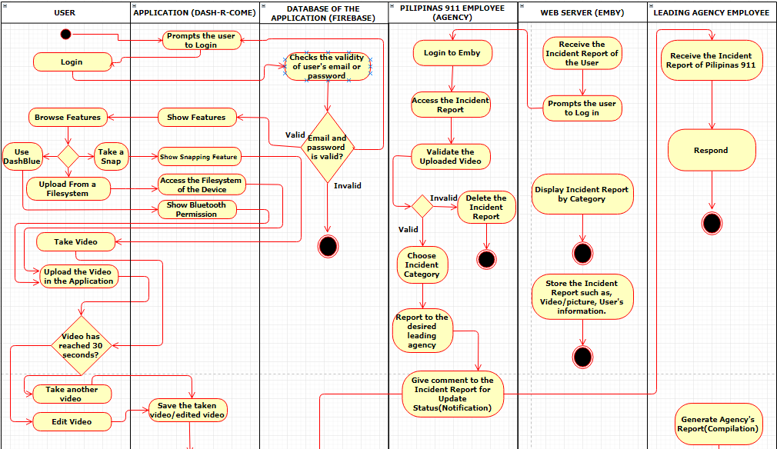

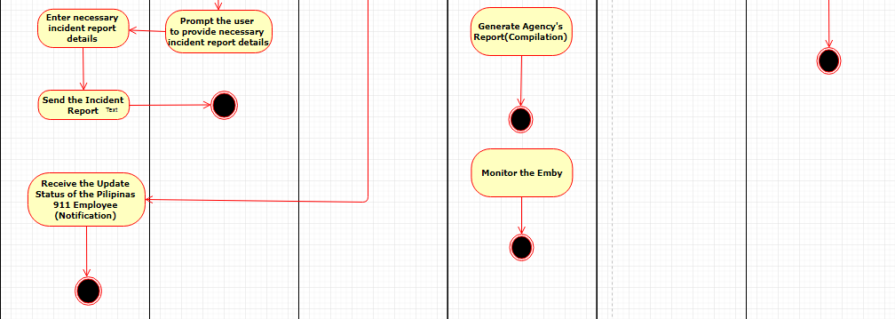

**l. Sequence Diagram**

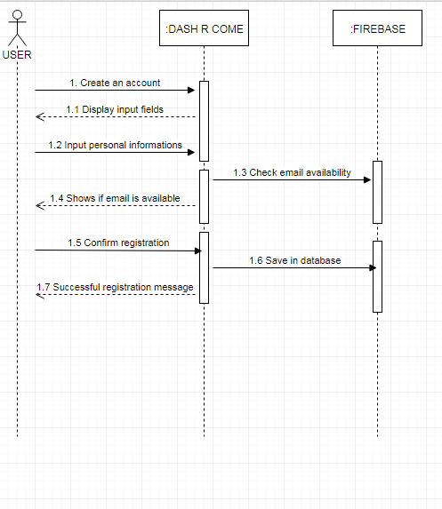

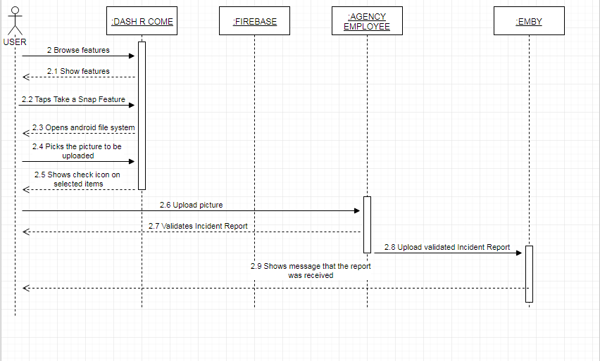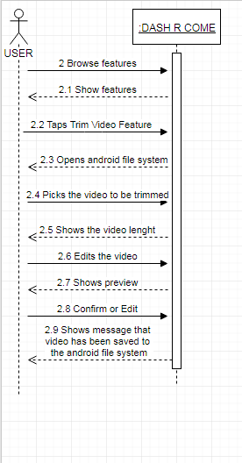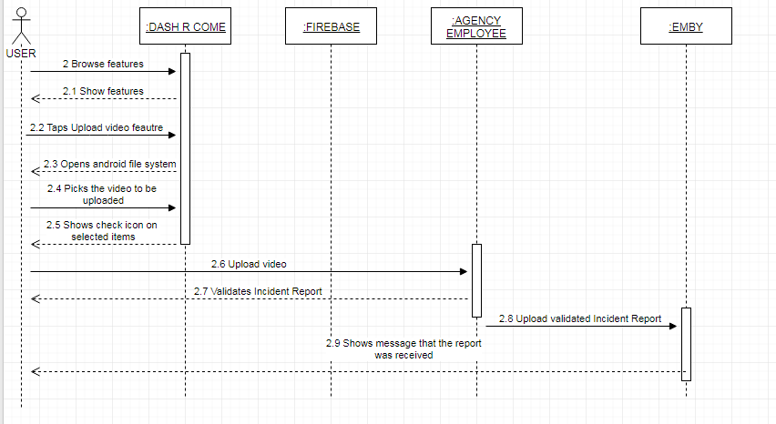

**M. Deployment Diagram**

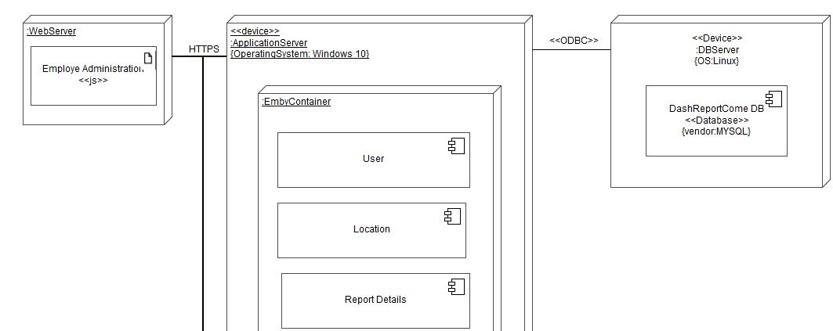

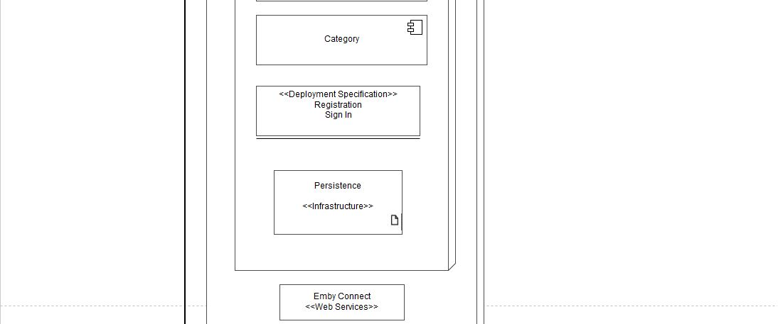

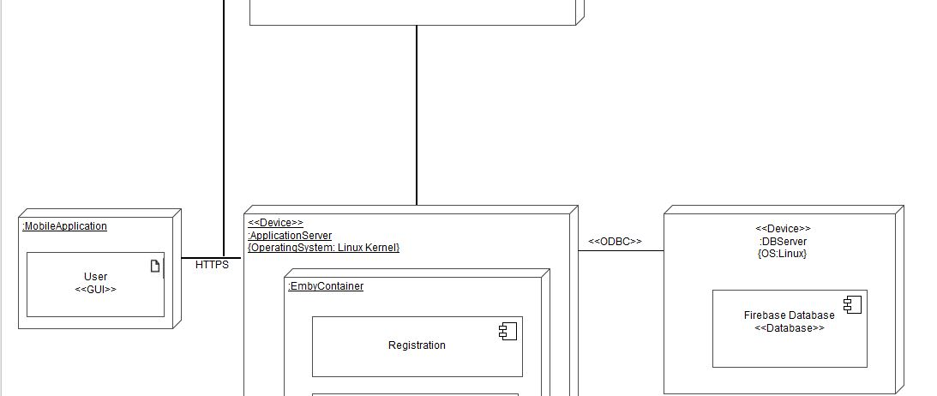

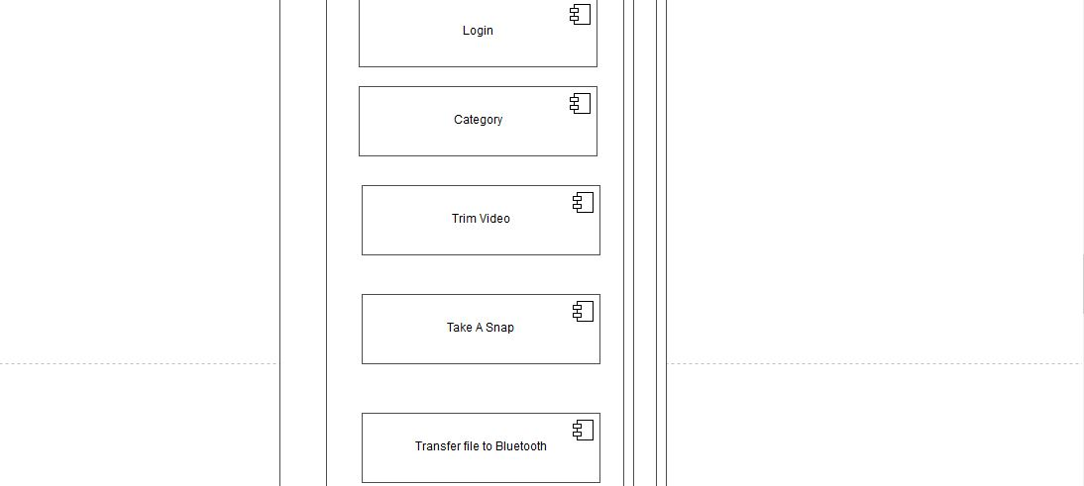



**N. Communication Diagram**

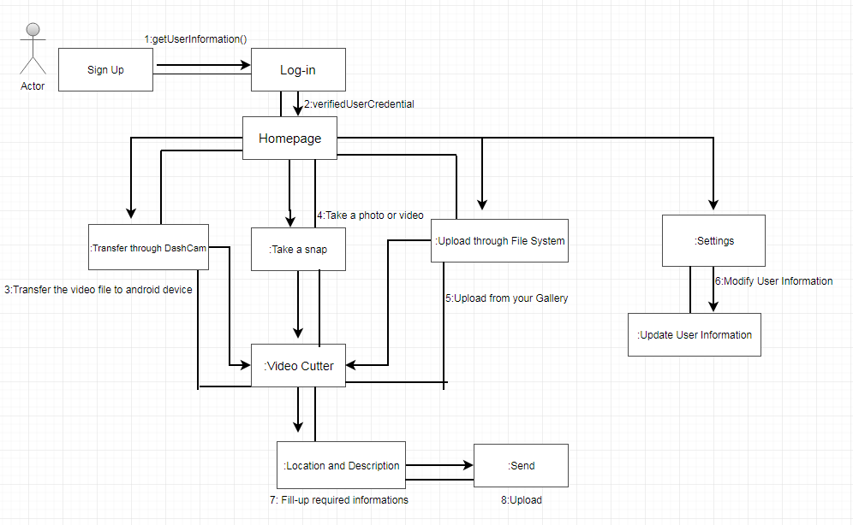

**O. Timing Diagram**

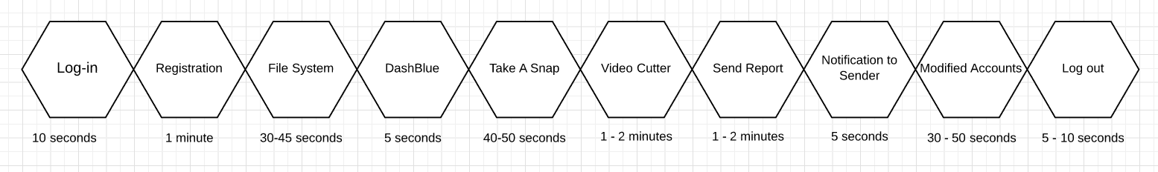

**P. Component Diagram**

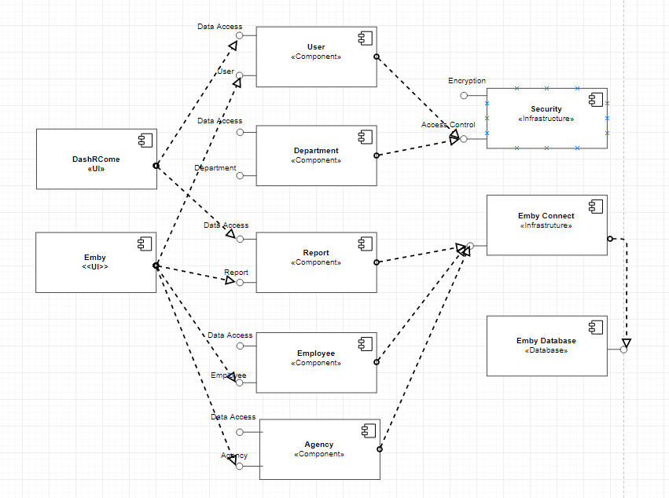

**Q. Package Diagram**

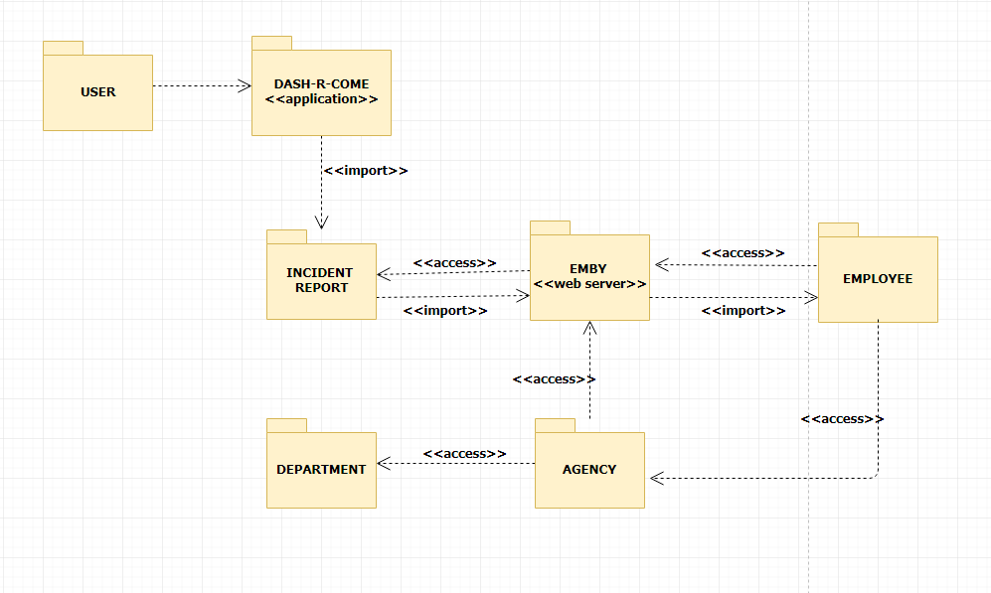

**R. State Diagram**

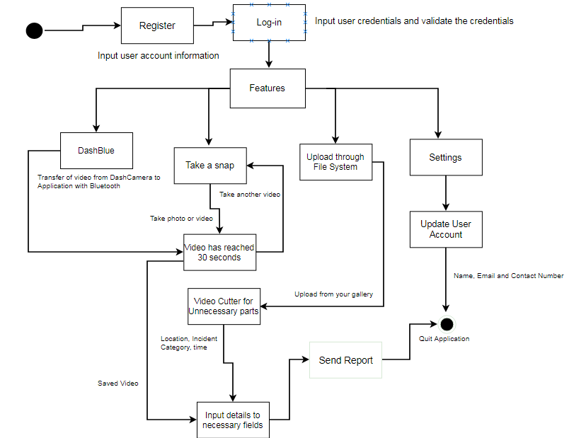

**S. Interaction Overview Diagram**

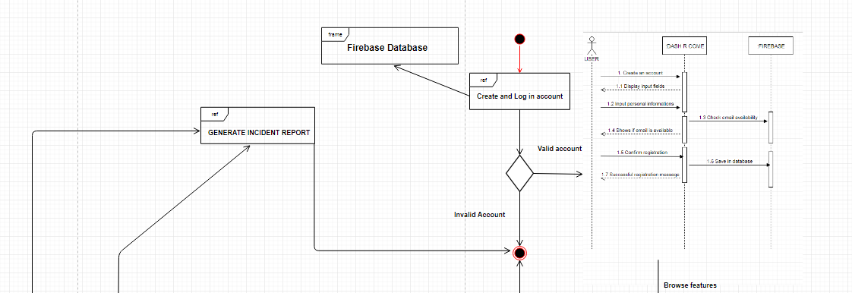

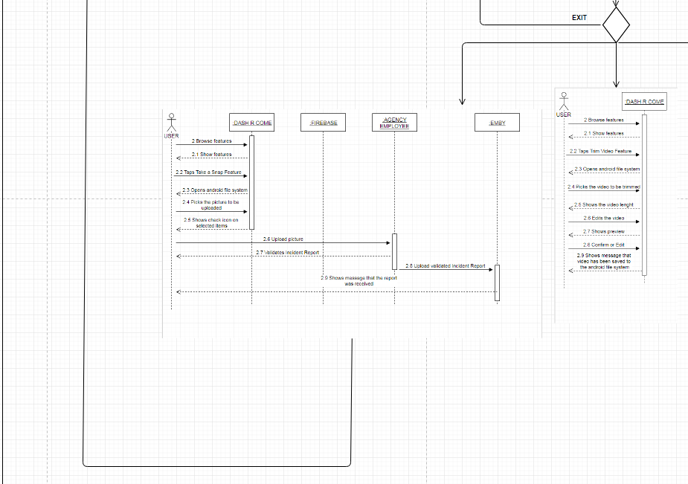

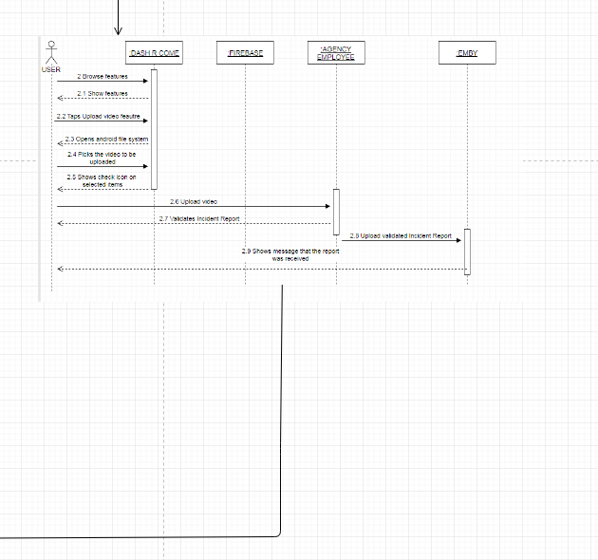

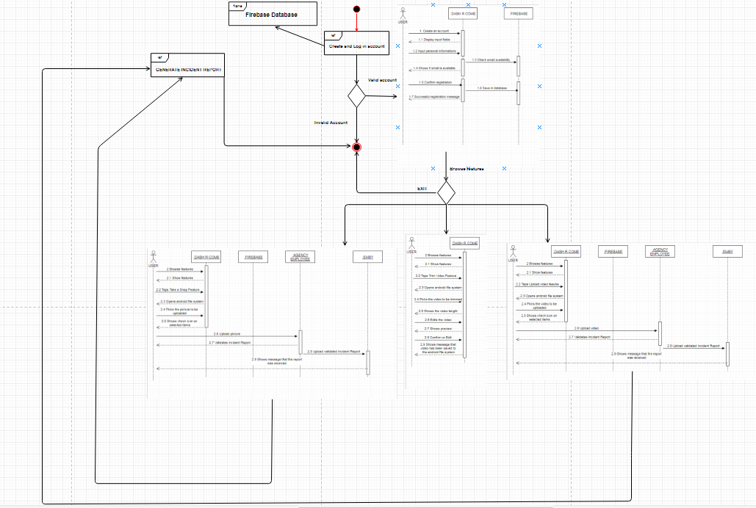

**V. Conclusions and Recommendation**

In today’s times, reporting a crime, traffic accident, or accusing of someone to a crime is hard to investigate if there is no evidence. A mobile application like Dash-R-Come could serve as an alternative tool in capturing and reporting an incident. Our proposed system aims to help the client get a real-time and detailed incident reports. Since the client’s biggest problem are prank reports.

Using the proposed system, the client will be able to avoid deploying their people unusably to respond on prank reports. Since there will be employees of Pilipinas 911 that will be monitoring, analyzing and categorizing the incident reports, it is assured that prank reports will be avoided.

## **Results of the Interview**

As the group identifies the factors that will help to improve the process in developing the proposed system, the group conducted an interview in Barangay Magallanes that contains 15 questions and lasted for 20 minutes, questions that includes the interviewee’s personal information, rules and regulations of Makati City traffic and common traffic problems and crimes that they usually encounter in their area. The data below is the result of the interview that the group conducted.

The name of the interviewee is Sir Jesus Sumandal, he is one of the Desk Officers in Barangay Magallanes. The Desk Officer is the one who receives complaints; also, he is in-charge in deploying people in an incident.

They are allowed to respond to all kinds of crimes and incident in the City of Makati. It is possible to respond in that area we asked. He told us that as long as the concern is in our area. We can respond with the participation in NDCC. The barangay of Magallanes Makati has a different divisions such as; Peace and Order, Accounting, Social Service, Health Clinic, Infrastructure, and Educational & Culture

They process the incident report as follows; Get the following information. Details of the incident, Description of the suspect, information about the complainant, what is the thing stolen, if the complainant will not file against the complainant and if the thing stolen has a big amount; How do they validate the report, The Barangay Officer will know if the complainant is lying or not, first in the interview. If the complaint is true, they will endorse it to CDI and do their process

They have allotted budget and resources. They have Wi-Fi connection and computers and a database. The team also asked the commonly committed crime in the Makati area. Sir Sumandal mentioned that, it is snatching and most victims APC students.

## **Results of the Interview**

Another Interview was conducted in Southern Police District Station 2; the purpose of the Interview was to verify how Pilipinas 911 works. The group submitted a Letter of Request for Interview in Pilipinas 911 agency on December 4, 2017, unfortunately, due to the full schedule of their Officer; they were not able to respond to our request. However, the group was able to conduct an Interview and verify the process of Pilipinas 911 in Southern Police District Station 2 since they are affiliated with Pilipinas 911. Police Chief Inspector Samuel Melchor Fernandez provided the team the informations needed from Pilipinas 911. Police Chief Inspector Samuel Melchor Fernandez is the Chief Station Operations and Plans Section Chief. Their station is responsible for operational planning and deployment.

The group asked about what are the most common incident reports that they encounter, Police Chief Inspector Samuel Melchor Fernandez mentioned that the most common incident reports that they encounter are; traffic incidents, snatching, robbery, theft in public utility vehicles. Also, he added that their biggest problem is prank reports.

Before the end of the Interview, he suggested that the project should be implemented to all departments, not just in Pilipinas 911, with that; the response time would be faster.

## Results of the Survey

Aside from doing an interview, the group also conducted an online survey that asks about the respondent’s knowledge about traffic rules and regulation, and if they know where and how to report to police / LGU in case of emergency and the proposed mobile application’s features.

# **Change Request**

|  |  |  |  |
| --- | --- | --- | --- |
| ORIGINAL PROPOSAL | WHAT CHANGE? | WHY? | WHEN? |
| Name of the Application: Dash Come | Dash-R-Come | We had change the process of the application and we matched the process of the application to the name of the application. | Finals during INTSDEV Course |
| Process of the Application:  User will upload the video of the incident after he/she cut the unnecessary part of the video then, it will be send to the database.    The employee in the agency who monitors the database will analyze the report of the user and afterwards, the employee will generate a report to be send in the desired agency, Hospital as an example.    And the personnel in the desired agency will process the generated report sent and will rescue. | User will upload the video of the incident after he/she cut the unnecessary part of the video then, it will be upload to the server, including the details of the video, information of the sender/user.    The server can access by anyone in the agency and will do the agency’s process to respond to the user. | As suggested by Sir Jayvee Cabardo, the group members saw as it can have an improvement of the application and will give the application …. | During Midterms in SYSADD1 and SYSADD2 Course |
| No incident category | Incident Category in the application and the server added | As suggested by Sir Jayvee and Sir Sean Sanchez to add a category of the incident report for the desired agency to be able to identify a specific incident happened and which agency is needed to respond to the user. | During Midterms in SYSADD1 and SYSADD2 Course |
| The application has the process of: if the user does not have an internet connection then it will just save the uploaded video in the device and will automatically send the video to the database. | Removed the process mentioned in the left side row. | As Sir Sean Sanchez checked our Event table, he suggested that the said process is impossible in the making. | During midterms in SYSADD1 and SYSADD2 Course. |

BARANGAY MAGALLANES INTERVIEW (latest)

Date: (Monday)   
Time: 11:30-1:30  
  
1. Name of Interviewee: Sir Jesus Sumandal  
2. Position/Work: Desk Officer Receives Complaints, Deploys barangay personnel.  
3. Scope and Limitations of their work: They can respond all types of crimes and incident.  
4. In Cities of Makati, what cases can they respond to? (For example, there is a report that an incident happened in highway, are they allowed to respond?)  
5. Does your Barangay have different divisions /departments? Yes.  
Departments:  
• Peace and Order  
• Accounting  
• Social Service  
• Health Clinic  
• Infrastructure  
• Education and Culture  
6. How do you process and file an incident report?  
They will get the following information:  
Details of the incident  
Description of the Suspect  
Information about the Complainant  
What is the thing stolen? (If it is a snatching incident.)  
If the complainant will not file a case against the suspect, then the suspect will just have to obtain 24 hours detainment in prison.  
If the thing stolen has a big amount of value, they will indorse the suspect to Precinct No. 4  
7. How do you validate a report?  
The Barangay Officer will know if the complainant is lying or not in the interview. If the complaint is true, they will indorse it to CDI and do their process mentioned in number 6.   
8. How do you generate an incident report?  
Documentation same as Blotter;   
Time?  
Situation?  
Case?  
Remarks? (Filed a case or not, Action made)  
5Ws and 1H (What, Why, Where, When, Who and How)   
9.What are the information required in processing a report?  
10.Do you have allotted budget/ resources for the project implementation?

11. Do you have computer and internet resources in your office? Yes.  
 Computer  
 Database   
 Wifi  
12. When the accident happened in the Skyway, do you have any participation in the rescue operation?  
Yes, they will respond but will indorse to PNCC because it is out of their scope.   
13. What is the most common committed crime in the Makati area?  
Snatching in SLEX most victims are APC students.

14. Who usually generates the report?  
Desk Officer, SIC

MAKATI INTERVIEW

1). Name: Police Chief Inspector Samuel Melchor Fernandez

2). Position/ Work: Chief of Station, Operations and Plans Section

3). Scope and Limitations of Work: They are the ones assigned to plan and deploy if there is an event.

4). What incidents do you respond to: Public safety, Traffic incident, crimes.

5). Different Departments connected to Makati Police District: Department of Health, Department of Finance, BFP (Bureau of Fire Protection), MMDA, etc.

6). Most common incidents reported - traffic incidents, robbery, snatching, theft (inside public vehicles

7). How do you validate an incident report? When they received an incident report, they deploy field units (10 exact field units in Makati) to confirm if the report is legitimate. Most reports are

Prank reports.

8). How do you generate an incident report? If the incident reported was validated, they generate incident report.

9). Resources for project implementation: Computer, Wi-Fi, and Phone

10). After you dispatch the incident to the other agency, what will happen next? If you required, the agency to update you back and you will call the caller again? The concerned agency will ask the caller for feedback if the agency fixed or satisfied their concern.

11). Do you have hotline for reporting? 911 take all the reports and the one who calls Makati Police District.

12). How do you handle reporters who needs immediate response? They immediately act if the call is from 911. Their goal is to respond within or earlier than 7 minutes. They deploy the nearest concerned unit to the incident area

13). Suggestion - implement to all the agencies, so that the reports and responses will be more efficient.

**Curriculum Vitae**

Personal Details

|  |  |
| --- | --- |
| Name: | Hurley John M. Evangelista |
| Complete Address: | MEQ U-2B BNS Fort Bonifacio, Taguig City |
| Contact Number | 09058149768 |
| Email Address: | [hmevangelista@student.apc.edu.ph](mailto:hmevangelista@student.apc.edu.ph) |



Educational Background

|  |  |
| --- | --- |
| Educational Attainment: | Asia Pacific College, Magallanes Makati City  Bachelor of Science in Information Technology with specialization in Mobile And Internet Technology  2015 - Present  Total Concept Integrated School - High School  Villamor Air Base Elementary School - Elementary |

Relevant Skills:

|  |  |
| --- | --- |
| Skills: | Android Programming  Web Programming  MySQL Programming |

Personal Details

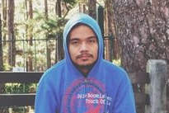

|  |  |
| --- | --- |
| Name: | Emmanuel Devera |
| Complete Address: | BLDG P USUSAN TAGUIG CITY |
| Contact Number | 09955573433 |
| Email Address: | [esdevera@student.apc.edu.ph](mailto:esdevera@student.apc.edu.ph)  BERTdevera28@protonmail.com |

Educational Background

|  |  |
| --- | --- |
| Educational Attainment: | Asia Pacific College, Magallanes Makati City  Bachelor of Science in Information Technology with specialization in Mobile And Internet Technology  2015 - Present  MCA Montessori School - High School  Nasugbu West Central School - Elementary |

Relevant Skills:

|  |  |
| --- | --- |
| Skills: | *SQL Programming  *C++ Programming  *Computer Security  *Network Security  *Web Designing |

Personal Details



|  |  |
| --- | --- |
| Name: | Alyssa Anne F. Fernandez |
| Complete Address: | Blk 9 Lot26 Burnham Park, Road 6, Talon 5, Teresa Subd. Las Pinas City |
| Contact Number | 09167449709 |
| Email Address: | [affernandez@student.apc.edu.ph](mailto:affernandez@student.apc.edu.ph) |

Educational Background

|  |  |
| --- | --- |
| Educational Attainment: | Asia Pacific College, Magallanes Makati City  Bachelor of Science in Information Technology with specialization in Mobile And Internet Technology  2014- Present  Pasay City South High School - High School  Villamor Air Base Elementary School - Elementary |

Relevant Skills:

|  |  |
| --- | --- |
| Skills: | * Android Programming * Web Programming * MySQL Programming * Java Programming |

Personal Details



|  |  |
| --- | --- |
| Name: | Miguel Enrico Matawaran |
| Complete Address: | 465G Protacio St. Pasay City |
| Contact Number | 09156410317 |
| Email Address: | mlmatawaran@student.apc.edu.ph |

Educational Background

|  |  |
| --- | --- |
| Educational Attainment: | Asia Pacific College, Magallanes Makati City  Bachelor of Science in Information Technology with specialization in Mobile And Internet Technology  2015 - Present  San Isidro Catholic School - High School and Elementary |

Relevant Skills:

|  |  |
| --- | --- |
| Skills: | Android Programming  Decision Making |